Webb Research Corporation

82 Technology Park Drive, E. Falmouth, MA 02536-4441 (508) 548-2077 FAX (508) 540-1686

USER MANUAL – APEX-SBE PROFILER
APEX-SBE INSTRUMENTS
Serial numbers 2154-2156

REV DATE 05-09-05
WRC Job no. 1128
Software Rev 02-11-02
Park and Profile with 28-bit ID
Including Pressure activation and First Profile in 24 hrs

I. ALKALINE BATTERY WARNING 2
II. Reset and Self Test 2
III. Deployment 4
IV. PARK and PROFILE Feature With deep profile first and pressure activation 5
V. ARGOS DATA 7
A. SERVICE ARGOS PARAMETERS 7
B. DATA FORMAT – 11 For 28-bit ID format 8
C. TEST MESSAGE FORMAT 11
D. Telemetry error-checking (CRC) 12
E. Conversion from hexadecimal to useful units 12
VI. MISSIONS 13
Appendix A: Flag Byte Description 14
Appendix B: CRC Algorithm in BASIC for 28 bit Id 16
Appendix C: Surface arrival time, and total surface time 17
APPENDIX D: Argos ID formats, 28 bit and 20 bit 19
APPENDIX E: Storage conditions 19
APPENDIX G Returning APEX for factory repair or refurbishment 19
APPENDIX G: CTD Calibration and Ballasting records 20

ALKALINE BATTERY WARNING

The profiler contains alkaline "D" cells.
There is a small but finite possibility that batteries of alkaline cells will release a combustible gas mixture. This gas release generally is not evident when batteries are exposed to the atmosphere, as the gases are dispersed and diluted to a safe level. When the batteries are confined in a sealed instrument mechanism, the gases can accumulate and an explosion is possible.
Webb Research Corp. has added a catalyst inside of these instruments to recombine Hydrogen and Oxygen into H2O, and the instrument has been designed to relieve excessive internal pressure buildup by having the upper end cap release.
Webb Research Corp. knows of no way to completely eliminate this hazard. The user is warned, and must accept and deal with this risk in order to use this instrument safely as so provided. Personnel with knowledge and training to deal with this risk should seal or operate the instrument. Webb Research Corp. disclaims liability for any consequences of combustion or explosion.

Reset and Self Test

Profilers are shipped to the deployment site in Hibernate mode. Shortly before deployment, reset the profiler by passing a magnet over the marked location on the pressure case. The profiler will run a self-test, transmit for 6 hours with the bladder extended, and then begin its pre-programmed mission.

The six ARGOS transmissions during self-test and the transmissions during the initial 6 hour period contain data about the instrument and are outlined in (V) ARGOS DATA, part (C) TEST MESSAGE FORMAT.

Procedure:
- Secure float in horizontal position, using foam cradles from crate.

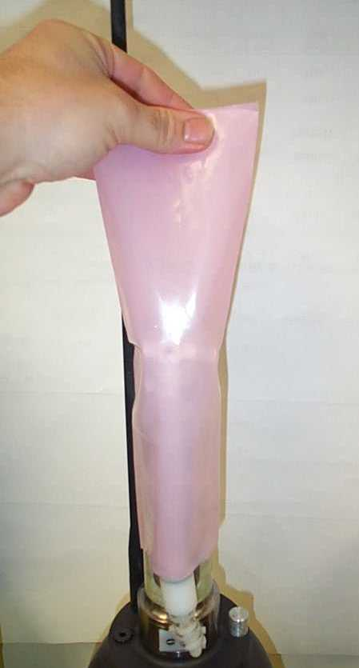
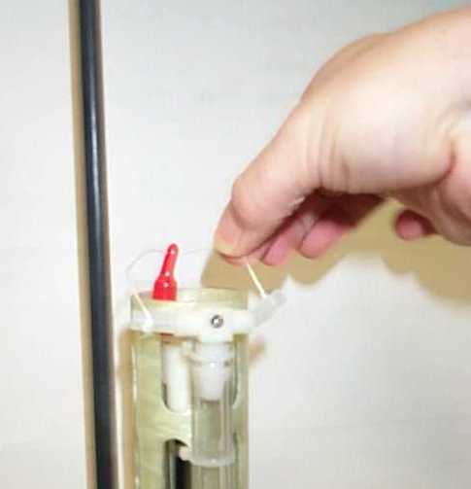
IMPORTANT: Remove plastic bag and three plugs from CTD sensor, if they have not already been removed.

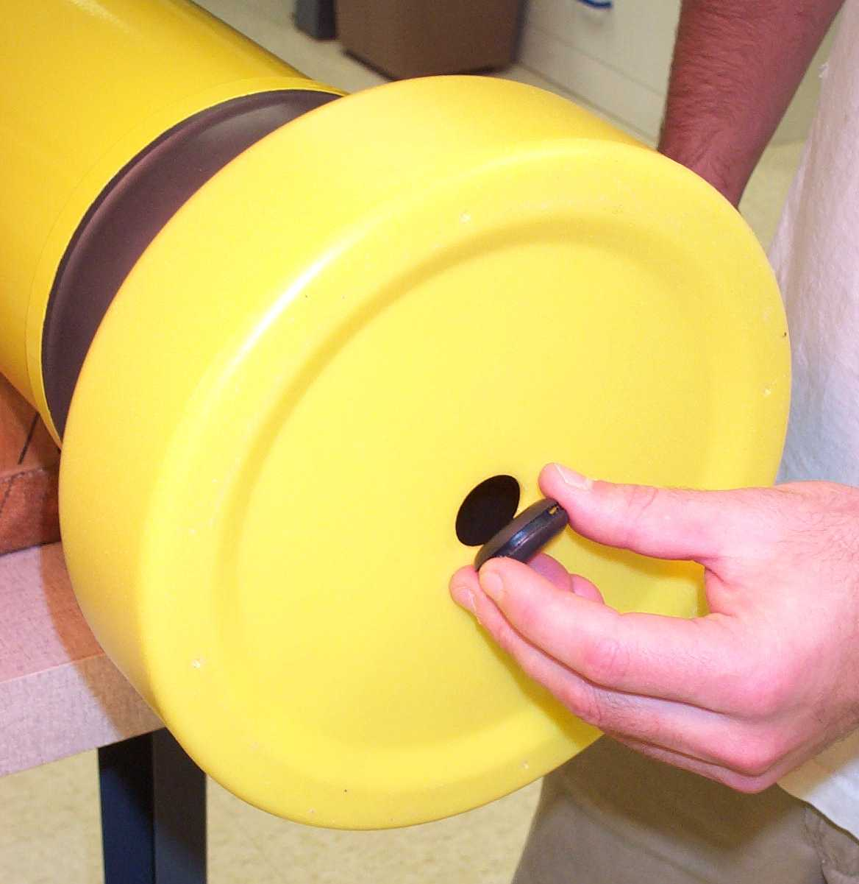
- Minimum temperature –2 deg C. If necessary, let float warm indoors before proceding.

- Carefully remove black rubber plug from bottom center of yellow cowing to verify bladder inflation (per below). Use fingers only- tools may puncture bladder. Be sure to replace plug before deployment.

Note: it can be very difficult to replace plug when air bladder is fully inflated. Replace plug during beginning of air bladder inflation.
Purpose of plug is to prevent silt entry if float contacts sea floor.

- Hold provided magnet at RESET position marked on for several seconds, then remove magnet.
Note: Magnetic switch must be activated (held) for at least one second to reset the instrument. (This is to provide a safety against accidental reset during transport.) Thus, if the float does not respond as below, the instrument was probably not reset.
- The air pump will operate for 1 second.
- The PTT will transmit 6 times at 6 second intervals. Place ARGOS receiver/beeper close to antenna to detect transmissions.
- The piston pump will begin to operate. The piston will move to the retracted Storage Position, if not already there, pause 2 seconds and then move to full extension.
- The oil bladder will expand, this should take 15 - 25 minutes.
- After the piston pump stops, PTT will transmit at specified ARGOS rate.
- At every PTT transmission, the air pump will turn on for 6 seconds until the air portion of the bladder has been inflated. The pump should turn on 8 – 10 times.
- 6 hours after reset, transmissions will cease, the bladder will deflate, and the piston pump will retract, the profiler begins its programmed mission.
- Reminder - replace black rubber plug in cowling hole before deployment.
During self-test, the controller checks the internal vacuum sensor. If the internal pressure has increased above a preset limit (i.e. hull leakage caused loss of vacuum), the instrument will not pump. If you do not detect the 6 test transmissions, and if the bladder does not inflate, then the self-test has failed and the instrument should not be deployed!

Deployment

- RESET instrument.
- SELF-TEST starts automatically (see above).
- When piston pump stops, air pump inflates, external bladder is full, PTT will transmit for 6 hours at ARGOS Repetition rate intervals. Typical repetition rate is 90 seconds or less. Programmed repetition rate can be found in the Missions section of this manual.
- If the repetition rate is 120 seconds the controller is not communicating properly with the CTD and the float should not be deployed.
- Six hours after reset, the piston pump will retract and bladder will deflate. Deploy before this time is up or reset the instrument again to re-initialize the 6 hour period. The purpose is to have the instrument on the surface and receive test transmissions.
- Pass a rope through the hole in the damper plate.
- Holding both ends of doubled up rope, carefully lower the float into the water. Do not let rope slide through hole in disk- this may cut the plastic disk.
- Take care not to damage the antenna.
- Do not leave the rope with the instrument, release one end and retrieve the rope.
- The float will remain on the surface until the 6 hour interval has expired.

PARK and PROFILE Feature With deep profile first and pressure activation
In summer of 2005 Apex software will have the option to do a deep profile quickly after deployment. This feature is being introduced in conjunction with a pressure activation safety feature.

Pressure activation
At a user settable interval, from the float menu, ranging from 2 hours to 21 days (or every 4 months as default) the float will move its piston to its park piston position. One hour later pressure will be checked. If pressure indicates that the float is below the surface, the float will auto start, as if reset, and begin test message sequence.

Auto start is programmable in float menu- parameter PA. Each value of 1-254 will be doubled into hours. A value of 255 will be converted into 120 days.

Webb Research strongly recommends that deployment procedures outlined in section II and in separate Apex Final Test Procedure document be followed. Pressure activation should only be used when absolutely necessary or as a safety feature when fully trained deployment personnel are not available.

Deep profile first sequence
After six hour surface Test message sequence is complete the float retracts piston and begins descent to profile depth.
If eight hours elapses and profile depth is not achieved, up time begins and ascent is started.
If profile pressure is achieved, the remainder of 8 hours, from end of test message sequence is added to Up time and a up cast profile is begun. Apex standard park and profile sequence continues as stated below.

APEX floats with park and profile feature can be set to profile from a maximum depth (profile depth) after a given number of profiles from a shallower depth (park depth).

Terminology:
PARK: intermediate depth at which the float drifts
PROFILE: maximum depth to which the float descends before profiling up.
DOWN time: spent during descent and at park depth.
UP time: includes ascent and time at surface.

Ascent rate: approximately .08 meters per second.

Total Up time is typically set to 12 to 20 hours, increasing proportional to depth and amount of data to be transmitted per profile. Another factor is deployment location: due to the polar orbit of ARGOS, the number of passes per day increases at high latitudes.
UP time
DOWN time
DEPTH
Park

Surface
TIME
Profile

Parameter PD determines the frequency of deep profiles.
Schematic examples:

PD = 1
deep profile every cycle

PD = 2
deep profile every 2nd cycle

ARGOS DATA

SERVICE ARGOS PARAMETERS
The user must specify various options to Service ARGOS. These choices depend on how the user wishes to receive and process data. Typical parameters are listed below:
- Standard location.
- Processing: Type A2 (pure binary input; hexadecimal output)
- Results Format: DS (all results from each satellite pass), Uncompressed.
- Distribution Strategy: Scheduled, all results, every 24 hours.
- Number of bytes transmitted: 31 per message*

Note: Webb Research strongly recommends all users to use ARGOS “Multi Satellite Service”, which provides receptions from 3 satellites instead of 2 for a small incremental cost.

* Using Argos 28-bit ID Format, 31 data bytes are transmitted in each message. With 20-bit ID Format, each message had 32 data bytes. (see Appendix D for more information).

DATA FORMAT – 11 For 28-bit ID format
Data are sent via ARGOS in 31 byte hex messages. The number of 31 byte messages sent depends on the programmed quantity of temperature measurements per profile. See appendix D

Format for message number 1 only:

Byte #
- 01 CRC, described in section C.
- 02 Message number, Assigned sequentially to each 32 byte message (Total number of messages per profile is shown below). Messages are transmitted in sequential order starting with 1 and incrementing by one for the data set.
- 03 Message block number, begins as 1 and increments by one for every ARGOS message data set. This, combined with the ARGOS repetition rate (section VI), allows the user to track surface drift. Byte 03 will roll-over at 256 and will reset to 1 on each new profile.
- 04 & 05 Serial number, identifies the controller board number. (This may not be the same as instrument number.)
- 06 Profile number, begins with 1 and increases by one for every float ascent.
- 07 Profile length, is the number of six byte STD measurements in the profile. Total number of bytes of STD data from each profile depends on the sampling strategy chosen.
- 08 Profile termination flag byte 2 -see section D
- 09 Piston position, recorded as the instrument reaches the surface.
- 10 Format Number (identifier for message one type)
- 11 Depth Table Number (identifier for profile sampling depths)
- 12 & 13 Pump motor time, in two second intervals. (multiply by 2 for seconds)
- 14 Battery voltage, at initial pump extension completion
- 15 Battery current, at initial pump extension completion, one count = 13 mA
- 16 Profile piston position (park and profile floats only)
- 17 Air bladder pressure measured in counts - approximately 148 counts
- 18 & 19 Park temperature, sampled just before instrument descends to target depth.*
- 20 & 21 Park salinity, sampled just before instrument descends to target depth.*
- 22 & 23 Park pressure, sampled just before instrument descends to target depth.*
- 24 Park battery voltage, no load
- 25 Park battery current
- 26 & 27 Surface Pressure, as recorded just before last descent with an offset of +5 dbar
- 28 Internal vacuum measure in counts- approximately 101 counts
- 29 Park piston position*
- 30 SBE pump Voltage
- 31 SBE pump current

Format for message number 2 and higher:

Byte #
- 01CRC, described in section C.
- 02 Message number
- 03 to 31 6 bytes- in sequence and continuing in the next message**
2 bytes temperature
2 bytes salinity
2 bytes pressure
**Note byte pairs will split between messages. For instance byte 31 of message #2 will contain half of the byte pair for the 5th pressure sample. The other half pressure byte will appear in byte 3 of message #3. See chart below.

Message Format and Sampling Depths
BTYE # | MSG 1
18 & 19 | Tp*
20 & 21 | Sp*
22 & 23 | Pp*
26 & 27 | Ps**

BTYE # | MSG 2 | BTYE # | MSG 3 | BTYE # | MSG 4
3 & 4 | Profile T | 3 | Half P4 | 3 & 4 | P9
5 & 6 | Profile S | 4 & 5 | T5 | 5 & 6 | T10
7 & 8 | Profile P | 6 & 7 | S5 | 7 & 8 | S10
9 & 10 | T1 | 8 & 9 | P5 | 9 & 10 | P10
11 & 12 | S1 | 10 & 11 | T6 | 11 & 12 | T11
13 & 14 | P1 | 12 & 13 | S6 | 13 & 14 | S11
15 & 16 | T2 | 14 & 15 | P6 | 15 & 16 | P11
17 & 18 | S2 | 16 & 17 | T7 | 17 & 18 | T12
19 & 20 | P2 | 18 & 19 | S7 | 19 & 20 | S12
21 & 22 | T3 | 20 & 21 | P7 | 21 & 22 | P12
23 & 24 | S3 | 22 & 23 | T8 | 23 & 24 | T13
25 & 26 | P3 | 24 & 25 | S8 | 25 & 26 | S13
27 & 28 | T4 | 26 & 27 | P8 | 27 & 28 | P13
29 & 30 | S4 | 28 &29 | T9 | 29 & 30 | T14
31 | Half P4 | 30 & 31 | S9 | 31 | Half S14

Sampling continues as shown above relevant to the number of depth table points sampled.
After the last data point in last message a Hex value of FFFF will fill remaining bytes.

* Tp, Sp, and Pp are Park Temperature, Salinity, and Pressure values
** Ps is surface Pressure
*** T, S, and P are Temperature, Salinity, and Pressure values
APEX records a profile during ascent (ie upcast). Bottom pressure may change due to several causes, such variation of insitu density, internal waves, float grounding in shallows, change of float mass, etc. APEX automatic depth adjustment will compensate in most, but not all, cases.

The number of sample points taken is proportional to depth, as per sample depth table below.
The first (i.e. deepest) sample is taken at the first point in the depth table above bottom pressure.

Depth Table No. 62

Sample | Pressure |  | Sample | Pressure | Sample | Pressure
Point |  | (dbar) | Point | (dbar) | Point | (dbar)
 |  | Bottom
1 |  | 1154 | 27 | 314 | 53 | 85
2 |  | 1098 | 28 | 299 | 54 | 80
3 |  | 1044 | 29 | 285 | 55 | 75
4 |  | 993 | 30 | 271 | 56 | 70
5 |  | 945 | 31 | 257 | 57 | 65
6 |  | 899 | 32 | 245 | 58 | 60
7 |  | 855 | 33 | 233 | 59 | 55
8 |  | 813 | 34 | 222 | 60 | 50
9 |  | 773 | 35 | 211 | 61 | 45
10 |  | 736 | 36 | 201 | 62 | 40
11 |  | 700 | 37 | 191 | 63 | 36
12 |  | 666 | 38 | 181 | 64 | 32
13 |  | 633 | 39 | 172 | 65 | 28
14 |  | 602 | 40 | 164 | 66 | 24
15 |  | 573 | 41 | 156 | 67 | 20
16 |  | 545 | 42 | 148 | 68 | 16
17 |  | 518 | 43 | 141 | 69 | 12
18 |  | 493 | 44 | 134 | 70 | 8
19 |  | 469 | 45 | 128 | 71 | 4 or surf
20 |  | 446 | 46 | 122
21 |  | 424 | 47 | 116
22 |  | 404 | 48 | 110
23 |  | 384 | 49 | 105
24 |  | 365 | 50 | 100
25 |  | 348 | 51 | 95
26 |  | 331 | 52 | 90

* The SeaBird CTD is not sampled at zero pressure, to avoid pumping the cell dry and/or
ingesting surface oil slicks. The shallowest profile point is taken at either 4 dbar or at the last
recorded surface pressure plus 5 dbar, whichever value is larger.

TEST MESSAGE FORMAT
The test message is sent whenever an I2 command is given, the six transmissions during the startup cycle, and during the six hour surface mode period prior to the first dive. Each test message has 31 Bytes, in hex unless otherwise noted, with the following format:

Byte #

- 01 CRC, described in section C.
- 02 Message block number, begins as 1 and increments by one for every ARGOS message.
- 03 & 04 Serial number, identifies the controller board number. (This may not be the same as instrument number.)
- 05 & 06 Time from start up, in two second intervals (Hex)
- 07 Flag (2) byte
- 08 & 09 Current pressure, in bar
- 10 Battery voltage
- 11 Current Bladder pressure, in counts
- 12 Up time, in hours
- 13 & 14 Down time, in hours
- 15 & 16 Park pressure, in bar
- 17 Park piston position, in counts
- 18 Depth correction factor, in counts
- 19 Storage piston position, in counts
- 20 Fully extended piston position, in counts
- 21 OK vacuum count at launch, in counts
- 22 Ascend time, in intervals
- 23 Target bladder pressure, in counts
- 24 & 25 Profile pressure, in bar
- 26 Profile piston position, in counts
- 27 Deep profile cycle counts
- 28 Pressure Activation value- 1-254 multiply by 2 for hours. 255 = four months
- 29 Month, software version number (in decimal).
- 30 Day, software version number (in decimal).
- 31 Year, software version number (in decimal).

* Flag (2) byte: 1 Deep profile **Flag (1) byte: 1 Trip interval time
2 Pressure reached zero 2 Profile in progress
3 25 minute Next Pressure timeout 3 Timer done
4 piston fully extended before surface 4 UP/ DOWN
5 Ascend time out 5 Data entry error
6 Test message at turn on 6 Measure battery
7 Six hour surface message 7 Piston motor running
8 Seabird String length error 8 Negative SBE number

Telemetry error-checking (CRC)
Because ARGOS data contains transmission errors, the first byte of each message contains an error checking value. This value is a Cyclic Redundancy Check (CRC), and is calculated as a function of the message content (bytes 2 to 32).

- For each message, calculate a CRC value
- Compare the calculated CRC to the transmitted CRC (byte no. 2)
- If the calculated and transmitted CRC values are not equal, the message has been corrupted and should be deleted before further data processing.

Appendix (B) lists a sample program (in BASIC) to calculate the CRC value for a message. This program can be provided upon request in Basic, Fortran or C

Conversion from hexadecimal to useful units
The pressure is measured every 6 seconds. Temperature, salinity and pressure are measured and stored at each point in the depth table. Two hex bytes are stored for each sensor. The decimal numbers from the STD sensors are converted to hex for compression in the ARGOS transmission as follows:
Temperature: 5 digits, 1 milli-degree resolution.
Salinity: 5 digits, .001 resolution
Pressure: 5 digits, 10 cm resolution.

To convert the hex ARGOS message back to decimal numbers:
hex → dec = converted units
Temperature: 3EA6 → 16038 = 16.038 C
Temperature*: F58B → 02677 = -2.677 C
Salinity**: 8FDD → 36829 = 36.829
Pressure: 1D4C → 7500 = 750.0 decibars
Current 0A→ 10 = 130 mA
Volts 99 → 153 = 15.7 volts
Voltage (V) = counts/10 + .4 (counts is in decimal number) nominally 15 V and decreasing.
Current (mA) = counts *13 (counts is in decimal number)
Vacuum (inHg) = counts *-0.209 + 26.23 (counts is in decimal number) nominally 5 inHg.
*Note regarding negative temperatures ( T °C < 0 )
Positive temperature range is 0 to 62.535C (0 to F447 hex)
Negative temperature range is -0.001 to -3.000C (FFFF to F448 hex).
If (hex value) > F448, then compute FFFF - (hex value) = Y
Convert Y to decimal = dec_Y
(dec_Y + 1) / 1000*-1 = degrees C

**The 5 most significant salinity digits are telemetered. The 6 digit salinity number is rounded up and converted to hex. 36.8286 rounds to 36.829 and converts to 8FDD.

MISSIONS
This section lists the parameters for each float covered by this manual.
The parameter listing appears when the float is RESET while connected to a terminal.
INSTRUMENT #2154
APEX version 02 11 05 sn 2423 011 062
05072AD ARGOS ID number.
044 seconds repetition rate.
240 hours DOWN.
013 hours UP.
1000 d-bar park pressure. P1
045 park piston position. P2
012 ascent rate correction. P3
100 storage piston position. P4
248 piston full extension. P5
1200 d-bar profile pressure. P6
022 profile piston position. P7
115 OK vacuum count. P8
007 hours ascend time. P9
120 days auto start check. PA
145 air bladder pressure. PB
001 deep profile count. PD
025 Initial piston extension.

INSTRUMENT #2155
APEX version 02 11 05 sn 2424 011 062
05072BE ARGOS ID number.
046 seconds repetition rate.
240 hours DOWN.
013 hours UP.
1000 d-bar park pressure. P1
045 park piston position. P2
012 ascent rate correction. P3
100 storage piston position. P4
251 piston full extension. P5
1200 d-bar profile pressure. P6
022 profile piston position. P7
115 OK vacuum count. P8
007 hours ascend time. P9
120 days auto start check. PA
145 air bladder pressure. PB
001 deep profile count. PD
025 Initial piston extension.

INSTRUMENT #2156
APEX version 02 11 05 sn 2425 011 062
05072C7 ARGOS ID number.
044 seconds repetition rate.
240 hours DOWN.
013 hours UP.
1000 d-bar park pressure. P1
045 park piston position. P2
012 ascent rate correction. P3
100 storage piston position. P4
251 piston full extension. P5
1200 d-bar profile pressure. P6
022 profile piston position. P7
115 OK vacuum count. P8
007 hours ascend time. P9
120 days auto start check. PA
145 air bladder pressure. PB
001 deep profile count. PD
025 Initial piston extension.

Appendix A: Flag Byte Description

Two memory bytes are used, one bit at a time, to store 16 different bits of program flow information. Both of these bytes are telemetered in the test messages sent at startup and for the initial 6 hour surface period. Only flag byte 2 is sent in the data messages, as part of message number 1. Bit one is set for each deep profile and bit 8 is set each time the last SBE sensor value used an arithmetic round up.

Below is a list of what each bit in each byte signifies.

bit
Flag (2) byte: 1 Deep profile
2 Pressure reached zero
3 25 minute NextP timeout
4 Piston fully extended
5 Ascend timed out
6 Test message at turn on
7 Six hour surface message
8 Seabird string length error

bit
Flag (1) byte: 1 Trip interval time
2 Profile in progress
3 Timer done (2 min bladder deflate time.)
4 UP/DOWN
5 Arithmetic round up
6 Measure battery while pumping
7 Piston motor running
8 Negative SBE number

The flag bytes are transmitted as two hex characters with four bits of information encoded in each character. Each hex character can have one of 16 different values as shown in the following table.

1 0 0000 10 9 1001
2 1 0001 11 A 1010
3 2 0010 12 B 1011
4 3 0011 13 C 1100
5 4 0100 14 D 1101
6 5 0101 15 E 1110
7 6 0110 16 F 1111
8 7 0111
9 8 1000
Bit 8 is the most significant bit and bit 1 is the least significant bit in the byte.

As an example: if a deep profile ended with the piston fully extended and ascend had timed out, then bits 1, 4 and 5 would be set in the termination byte. This binary pattern, 0001 1001, would be transmitted as the two hex characters, 19.

As another example: if a regular profile ended with the piston fully extended and the 25 minute next pressure had timed out, then bits 3 and 4 would be set in the termination
byte. This binary pattern, 0000 1100, would be transmitted as the two hex characters, 0C.

Appendix B: CRC Algorithm in BASIC for 28 bit Id

Below is a sample program (in BASIC) to calculate the CRC value for a message. This program can be provided upon request in Basic, Fortran or C.

DECLARE FUNCTION CRC% (IN() AS INTEGER, N AS INTEGER)
‘CRC routine to check data validity in ARGOS message.
‘Bathy Systems, Inc. RAFOS Float data transmission.
‘3 December, 1990.
‘The 1st of 31 bytes in an ARGOS message is the CRC.
‘The function CRC will compute CRC for byte 2 through 31.
‘Hasard is used for Random because Random is reserved by BASIC.
‘Stored as file CRC in C:\RAFOS\RAF11.
DECLARE SUB Hasard (ByteN AS INTEGER)

DEFINT A-Z

DIM in(31) AS INTEGER
‘RAF11F message number 08 HEX ID 11502 01-02-93 CRC is O.K.
A$ = "d802075d87c64e15078187c64c1f07b287c74a3007ce87c6483f07fe87c246"

N = 31

FOR I = 1 to N
in(I) = VAL(“&H” + MID$(A$, 2 + I - 1, 2))

NEXT I

PRINT in(1); CRC(in(), N);

FUNCTION CRC% (IN() AS INTEGER, N AS INTEGER) STATIC

DIM ByteN as INTEGER

I = 2
ByteN = in(2)

DO
CALL Hasard(ByteN)

I = I + 1
ByteN = ByteN XOR in(I)

LOOP UNTIL I = N
CALL Hasard (ByteN)
CRC = ByteN

END FUNCTION

DEFINT A-Z

SUB Hasard (ByteN AS INTEGER) STATIC
x% = 0
IF ByteN = 0 THEN ByteN = 127: EXIT SUB
IF (ByteN AND 1) = 1 THEN x% = x% + 1
IF (ByteN AND 4) = 4 THEN x% = x% + 1
IF (ByteN AND 8) = 8 THEN x% = x% + 1
IF (ByteN and 16) = 16 THEN x% = x% + 1
IF (X% AND 1) = 1 THEN
ByteN = INT(ByteN / 2) + 128

ELSE
ByteN = INT(ByteN / 2)

END IF

END SUB

Appendix C: Surface arrival time, and total surface time

Some users may wish to determine surface arrival time, and total surface time, in order to calculate drift vectors.

Although each 31-byte message is time-stamped by ARGOS, there may not be a satellite in view when the float surfaces.

When the float surfaces (ie detects surface pressure recorded before last descent) it will begin ARGOS telemetry. Messages are transmitted in numerical order, starting with message no. 1.
When all messages have been transmitted, the cycle starts again at message no. 1.

Elapsed time since surfacing (Te)

Te = (m-1)*n*r
Where: m = message block number (byte 03 of message 01)
n = total number of messages to transmit profile
r = repetition rate

Total number of messages (n) is described in section IV (b), or may be determined from the ARGOS data. Note (n) may be less than specified in user manual if the float is operating in shallow water, causing reduced profile length.

Repetition rate (r) is the time interval between ARGOS transmissions. This value can be determined from section V, or from the ARGOS data.

Approximate time of surfacing

Subtracting Te from the ARGOS time stamp can determine approximate time of surfacing

Example

Below is message 01 in DS format

2001-11-02 22:47:54 1 CF 01 05 02
AF 02 2F 00
85 01 01 01
16 92 17 19
9E 94 01 AD
85 09 1F 48
97 9B 00 46
62 24 0E

m = message block number (byte 03) = 5
n = total number of messages to transmit profile = 11
r = repetition rate = 62 seconds

Te = elapsed time since surfacing = (m-1)*n*r = (5-1)*11*62 s = 2728 s = 00h 45m 28s

Approximate time of arrival at surface:
ARGOS time stamp - Te = 22:47:54 - 00:45:28 = 22:02:26

Total time spent at surface transmitting (Tsurf):

This is determined by subtracting ascent time from UP time.
Tsurf = (UP time, hr) - (bottom pressure)/(ascent rate 0.08 dbar/s)/3600

Bottom pressure is telemetered as bytes 7 & 8 of message 02.

Example:

For bottom pressure of 2000 dbar, and UP time of 18 hours
Tsurf = (18 hr) - (2000/0.08/3600) = 11 hr

APPENDIX D: Argos ID formats, 28 bit and 20 bit

In 2002 Service Argos notified its users there were a limited number of 20-bit Ids available and to begin preparing for a transition to 28-bit IDs. The 28 bit-IDs reduced from 32 to 31 the number of data bytes in each message. Data provided by Argos will consist of 31 hex bytes per message. Data acquired by use of an uplink receiver will consist of 32 hex bytes per message. The first byte, when using an uplink receiver, is a 28-bit ID identifier used by Argos and is not represented in the Apex Data formats included in this manual.

APPENDIX E: Storage conditions
For optimum battery life, storage temperature range is +10 to +25 degrees C. When activated, the floats should be equilibrated at a temperature between -2 and +54 degrees C.
If optional VOS or aircraft deployment containers are used, these must be kept dry, and should be stored indoors only.

APPENDIX G Returning APEX for factory repair or refurbishment
Contact WRC before returning APEX floats for repair or refurbishment.
All returns from outside USA, please specify our import broker:
Logan International Airport, Boston
c/o DHL-Danzas Freight Forwarding Agents,
Phone (617) 886-5605, FAX (617) 241-5917
500 Rutherford Avenue, Charlestown, MA 02129
Note on shipping documents: US MADE GOODS

APPENDIX G: CTD Calibration and Ballasting records

